
To: | Dr. Thomas Mackin, Mechanical Engineering, Cal Poly SLO, tmackin@calpoly.edu
From: | Caiden Bonney
Date: | January 15, 2025
RE: | Week 1 Lab Assignment Design of a Shaft
I used an Excel spreadsheet to calculate reaction forces, torques, and moments at all locations along the shaft. All values colored orange can be adjusted with real time results. This adaptability allows for any small adjustments in the design constraints such as the loading that may be placed on the shaft. Due to every force’s location and magnitude being adjustable there is transferability between any problems with the same number of forces and gears acting upon a shaft with minor additions. The maximum net moment acting upon the shaft is noted and the moment can be found at any specific location needed such as at the location that shoulders were chosen to be placed at. The first half of the spreadsheet is mainly for moment calculations noted in Figure 1.
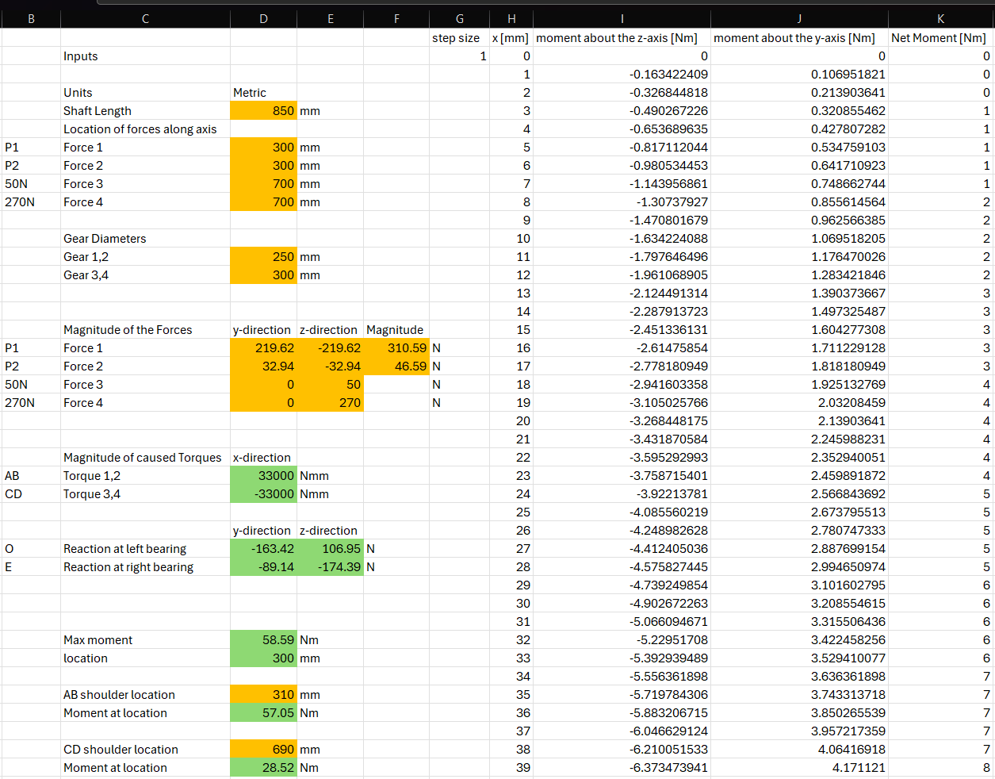
Figure 1. Moment Calculations Spreadsheet
From these net moment calculations, the minimum estimated diameter needed for infinite life can be calculated in Figure 2 with some additional information about the design. Inputs include estimated fatigue factor of safety, strength of materials, as well as the estimated stress concentration factors. Based on this information, the estimated minimum diameter of the shaft for infinite life under the specified conditions can be calculated including a rounding function up to the nearest 0.01 cm. Additionally given a yield strength for the material, a yield factor of safety can be calculated for a shaft of the minimum diameter.
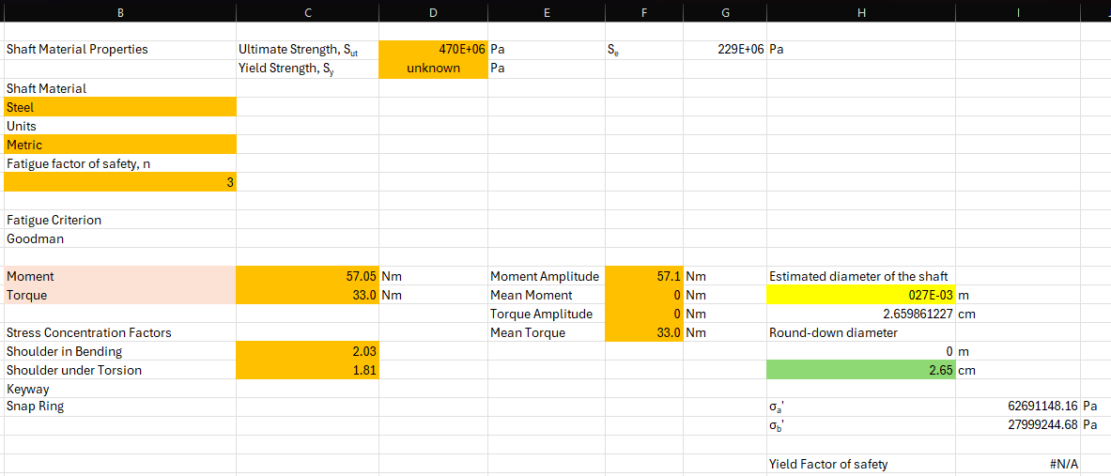
In Figure 1 the moment calculations spreadsheet shows a portion of the calculations used to plot the net moment as a function of location along the shaft. This is plotted in Figure 3 with vertical lines at the locations of shoulders such as the shoulder at x = 310mm and x = 690mm.
Figure 2. Diameter Calculations Spreadsheet

Figure 3. Net Moment vs Position
To better describe the locations of the shoulders a diagram of the basic shape of the shaft is noted below with adjustable shaft shoulder locations in the moment calculations spreadsheet. Figure 4 is a diagram to the same scale as Figure 3 for easy comparison of location along shaft, including proximity to a shoulder and the varying value of net moment.

Figure 4. Diagram of shaft displaying shoulder placement against position
The diameters noted in Figure 4 match the same dimensions as the tested diameters shown in the FEA section. The bending moments associated with the location of highest stress for the 3cm diameter was σ_{AB} = 58.11 MPa at shoulder AB located at x_{AB} = 310mm and σ_{CD} =29.05 MPa at shoulder CD located at x_{CD} = 690mm.
FEA:
As shown in Figure 4 the ends of the shafts have a diameter of 30cm with the middle portion having a diameter of 45cm. with a r/d=0.02 the radius at each shoulder is 0.60mm.
To best match bearings on a shaft two spherical divots were removed from each side of the shaft with a frictionless constraint placed on this spherical surface. This allows the shaft to both bend freely while still holding the shaft in the x, y and z planes and still allowing freedom to spin with no friction which is very similar to how real bearings can hold a shaft by butting up against shoulders while still allowing the shaft to spin at high speeds due to their low internal frictions. This extra freedom allows the shaft to bend even further, leading to higher stresses during the design process. This means that the safety factor may be higher than calculated accounting for some of the smaller assumptions made while simplifying the problem so that it could be modeled.
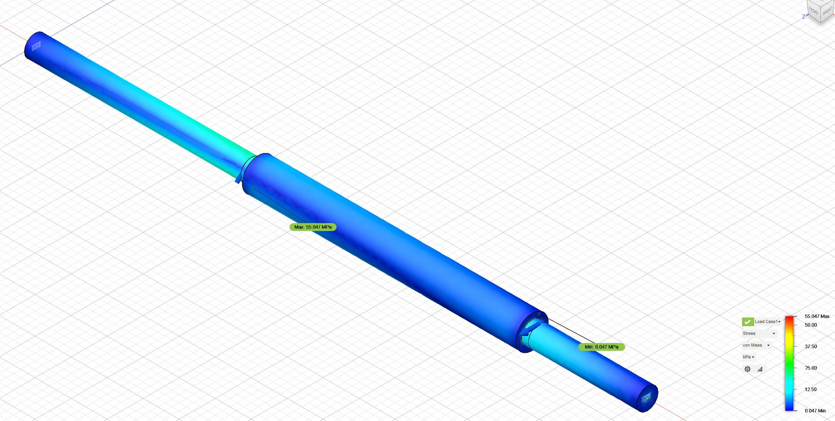
Figure 5. Von Mises Stress Distribution for Forces Only
The maximum stress at the 0.60mm fillet was found to be 55.047 MPa. Using,
$$\begin{aligned}k_{t}=\frac{σ}{\frac{32M}{πd^{3}}}\#\left(1\right)\end{aligned}$$
The $k_{t}$, calculated is 2.56 which is quite close to the $k_{t}$ of 2.7 that was used to find the diameter of 3 cm used in the FEA. They may be different due to the way that FEA calculates stress based on each finite segment as there is more error with larger segments. The original value of 2.7 may also be an overestimate as it is better to overestimate stress concentrators than underestimate them and have a catastrophic failure of a shaft.
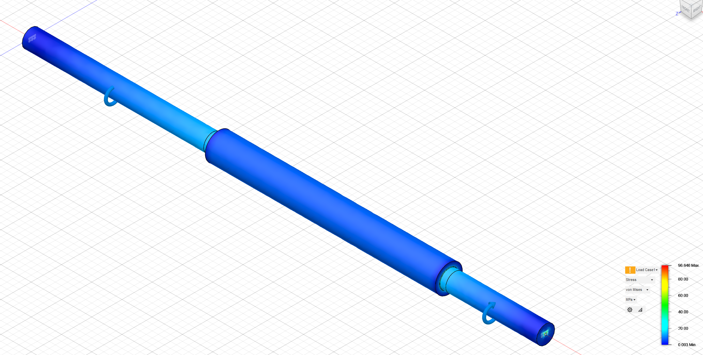
Figure 6. Von Mises Stress Distribution for Torques Only
The maximum stress at the 0.60mm fillet was found to be 22.294 MPa. Using,
$$\begin{aligned}k_{ts}=\frac{0.577*σ}{\frac{16T}{πd^{3}}}\#\left(2\right)\end{aligned}$$
The $k_{ts}$, calculated is 2.07 which is quite close to the $k_{ts}$, of 2.2 that was used to find the diameter of 3 cm used in the FEA. As stated before, they may differ due to the way that FEA calculates stress based on splitting the geometry into portions that are generalized and using smaller segments may result in a more accurate result. Another possibility is that the FEA torque setup was incorrectly done resulting in stresses that are unrealistic to the application attempted to be modeled.

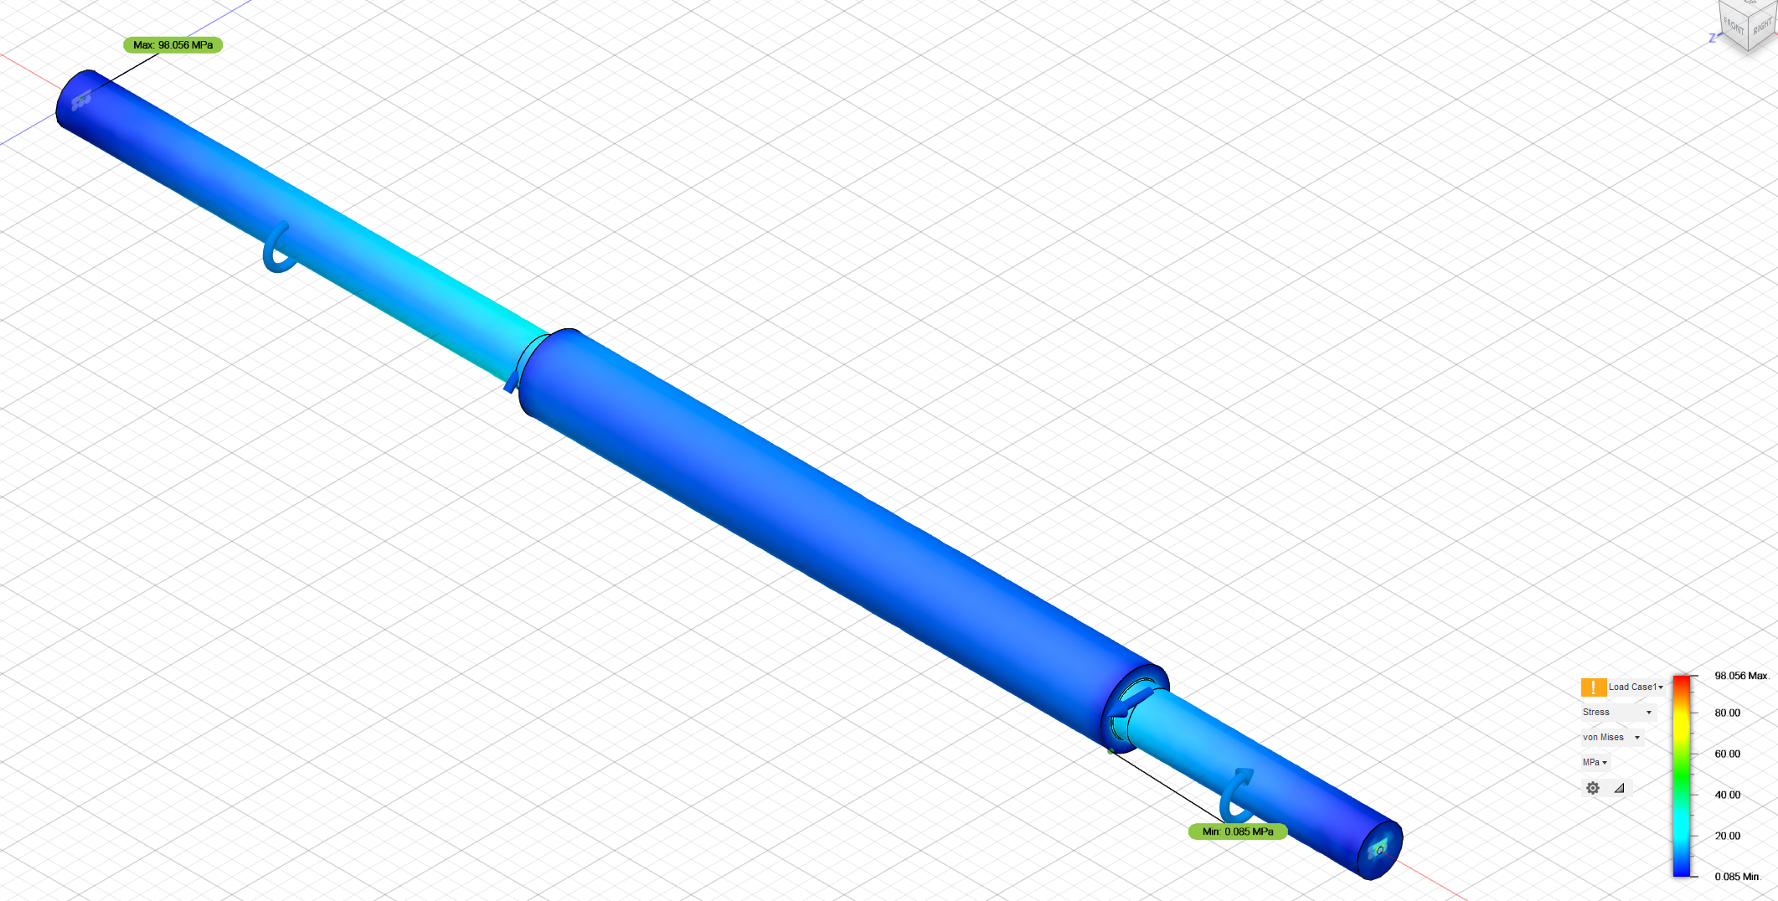
Figure 7. Von Mises Stress Distribution for Combined Loading r/d=0.02
The peak von Mises stress is 98.056 MPa however this is located in the spherical divot used to represent bearings holding the shaft. Ignoring these abnormally high stresses near the constraints the highest stress point in the fillet is 57.893 MPa which is much closer to the expected value based on previously stated calculations.
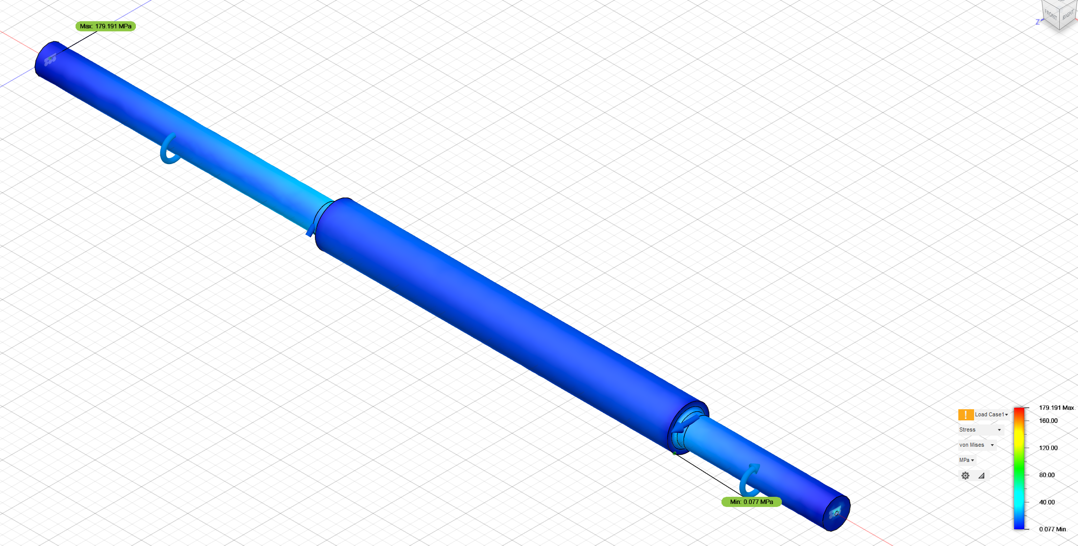
Figure 8. Von Mises Stress Distribution for Combined Loading r/d=0.1
With a fillet ratio of r/d=0.1 the radius is 3mm with such a large radius the maximum stress at the shoulders should drop drastically. As noted in comparing Figure 7 to Figure 8 at their fillets. Figure 7 got as high as 57.893 MPa while the peak von Mises stress at the shoulder for the 3mm fillet is 37.473 MPa. This is a much lower result as expected with such a slow change in diameter “funneling” the stress more smoothly to the smaller diameter shaft.

